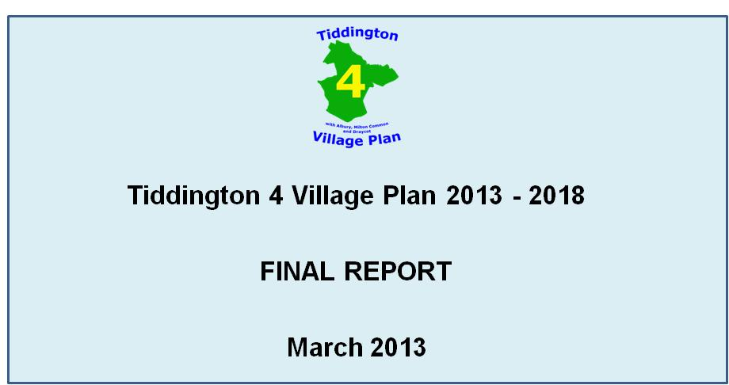

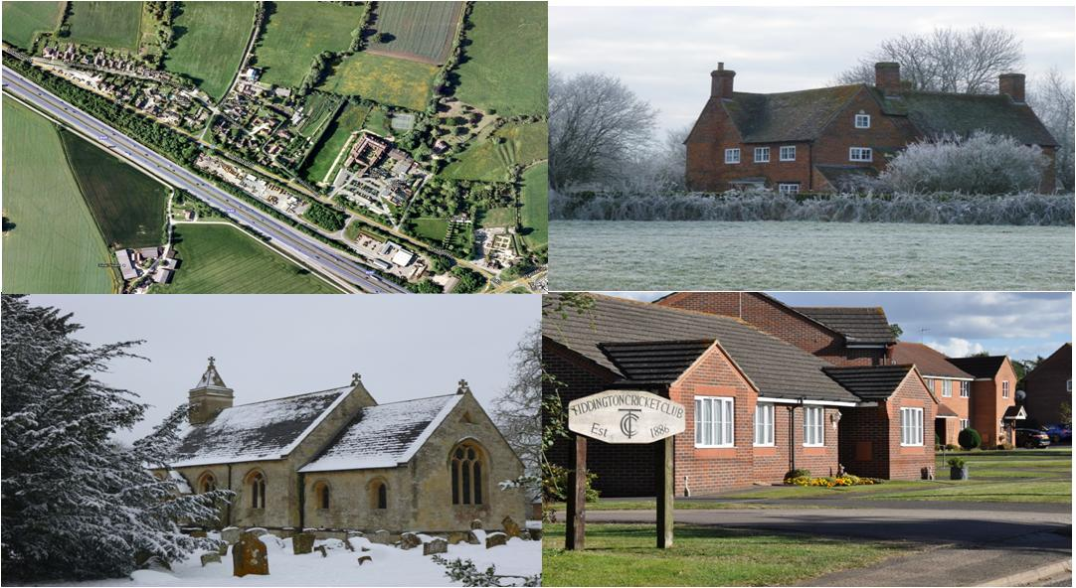

Introduction
On Monday 25 July 2011 a meeting arranged by the parish council to discuss the idea that there should be a village plan for the parish was attended by 53 residents. It was overwhelmingly agreed this was a good idea and a steering committee was formed immediately, comprising those who volunteered at the meeting.
Supported and guided by Oxfordshire Rural Communities Council, and with funding from the parish council and Oxfordshire County Council, the Steering Group has now produced this plan. This has involved more than 20 steering group meetings, two events where residents were invited to express their views directly, a news bulletin and a questionnaire to every resident and close liaison with the parish, district and county councils.
The questionnaire is the heart of the process. The topics addressed in it were those the residents said consistently were the ones that concerned them. The recommendations presented here reflect the answers and levels of priority residents gave in their answers to it. Therefore the plan is an expression of the preferences of residents and, as such, a guide to the actions of the parish council, which will be responsible for adopting and implementing it.

Our Parish
According to a profile produced in March 2011 the 4 villages of Tiddington, Milton Common (west), Albury and Draycot are home to a total of 640 residents, including 110 children under the age of 15 years and 123 adults of pensionable age.
In comparison with the rest of Oxfordshire we are mostly either very similar to or better than average, in terms of our housing, health, access to services, employment and skills.

Respondents to the Questionnaire
Some 370 completed questionnaires were received. The graphs below provide a simple profile of the respondents.
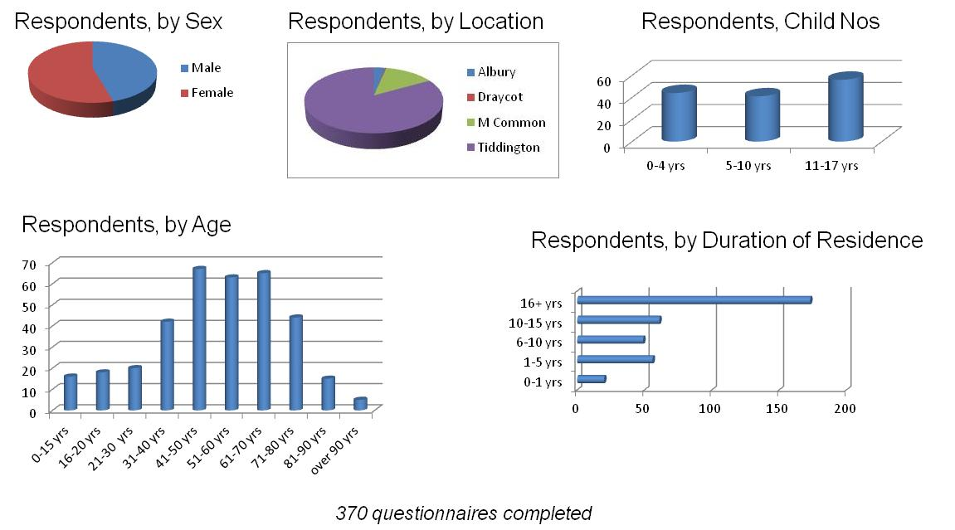

Findings & Recommendations
Roads
The provision of a pedestrian crossing over the A418 in Tiddington has been a major issue for many years, and one was almost installed until recent cuts in local government funds were made.
Two thirds of respondents to the questionnaire wanted a controlled crossing of the A418 in Tiddington, with the very large majority preferring a pelican crossing. A majority of respondents were willing to help raise funds for a crossing, especially a pelican crossing, but respondents were also clearly unsupportive of an increase in local taxes to pay for the crossing.
The County Council has made a revised estimate of £70,000 capital cost for a pelican crossing and associated street lighting, and informally advised they are neither able nor willing to provide the crossing.
We recommend:
- The PC organises and supports further fund raising for a pelican crossing
- The PC continues to press the case for a pelican crossing to the District and County Councils

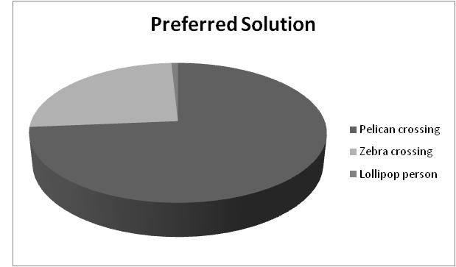

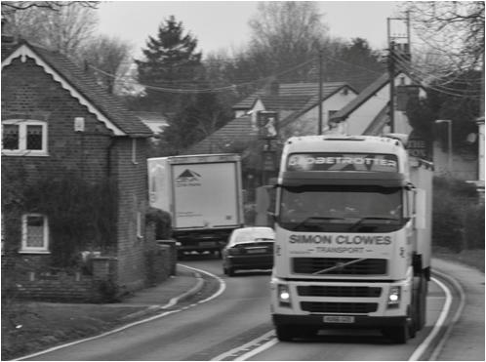
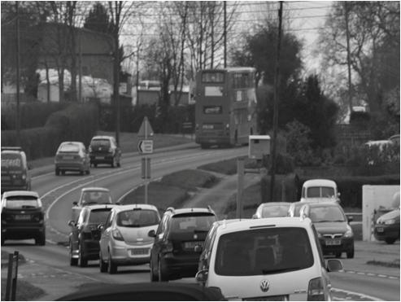
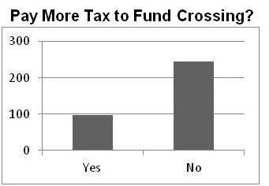

Environment & Flooding
Dog Fouling and Littering – Villagers were asked separately about Dog Fouling and Littering, and responses to both questions were almost identical. In both cases around 40% of respondents felt there was a problem, and the favoured responses were provision of more bins and penalising offenders. Therefore we recommend:
- The PC organises increased levels of litter picking, utilising volunteers from the survey
- The PC considers provision of additional litter and dog bins and prepares a plan for identifying and penalising offenders
Some interest was expressed in the provision of a skip for removal of larger household waste. We recommend:
- The PC consider reintroduction of a public skip
Street Lighting – Respondents were almost equally divided as to whether or not we have too little or too much street lighting, with the former having a very slight majority. Given the numbers involved (155 :147) we recommend :
- The PC should investigate the issue further, and consult on any specific proposals for installing more street lights
Noise - Only 14% of responses said affected “Lots” –main culprits are air & road traffic. Therefore we make no recommendations regarding noise.
Flooding - 86% of respondents have not suffered flooding here. Almost identical percentages of respondents have not taken their own steps to prevent flooding and think it important or very important the council takes action to prevent flooding. We recommend:
- The PC engages with the District Council and the Environment Agency to produce a local flood prevention and emergency management plan.

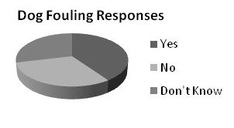
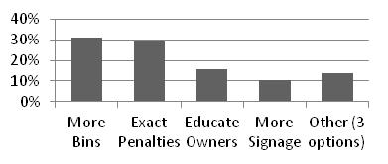

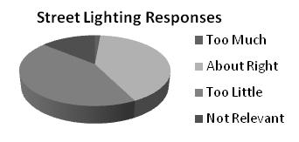
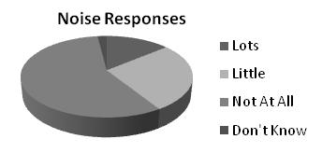
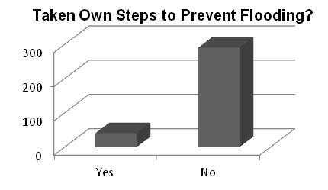

Support Services
All 4 suggested activities to support children and adolescents received more than 40 expressions of interest in at least occasional use, with weekend activities for children attracting most interest. However, indications from neighbouring villages are that more than 100 children actively using such schemes are needed to make them practically and economically viable. Therefore such activities will only be possible in co-operation with neighbouring populations. We recommend:
- The PC investigates interest in and availability of schemes to support children and adolescents in neighbouring villages.
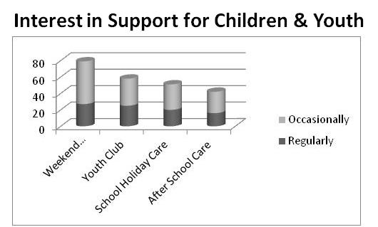
The Village Plan Steering Group has already successfully introduced a monthly coffee morning at the cricket club. The event is open to all ages but is predominantly used as a meeting place for older people, and to date average attendance has been well above 20 people per month.
Most elderly people or those with a disability or mobility problem wanted no support, but there were more than 15 expressions of interest for each of gardening, collecting prescriptions and transport to hospital or GP
We recommend:
- The PC identifies volunteers and checks any statutory etc requirements for providing support to the elderly and the disabled

Housing
We are not aware of any specific proposals for housing developments in the parish, nor in asking these questions were we seeking to suggest a view either in favour or against further housing development. We saw the questionnaire as an opportunity for residents to express their opinions on a number of potential scenarios, which they have done.
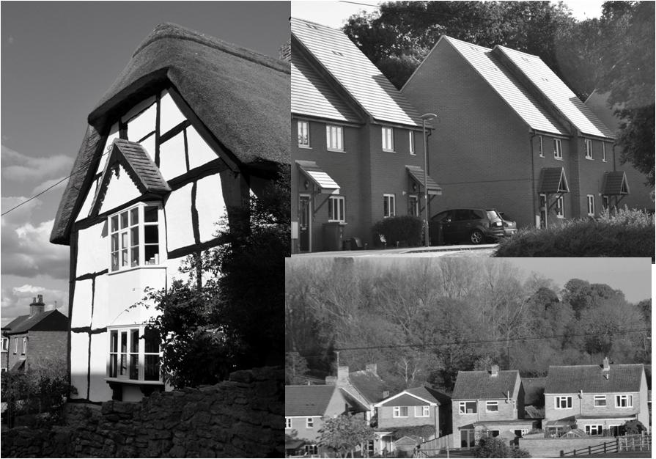
Just over 50% of respondents would potentially support / accept housing development in the parish if plans were put to the council, whilst just over 25% favoured no more development.
If the parish were to have new housing development, respondents highest preferences were for housing for people with local connections only then affordable housing to buy/ shared ownership
A very large majority preferred low-cost homes (shared equity, public social rented) to be allocated to people who have an existing family or other close connection with the parish.
We do not propose any recommendations, but simply advise the parish council of the views expressed.

Recreation & Leisure
We asked residents what leisure activities and sports they would be interested in doing, which is currently not available.
The following activities had a strong positive response of more than 40;
- Film club
- Computer, language, cooking and art classes
- Tennis
- Activity Trail in play area
- Outdoor Gym for adults
The next step is to test the viability of these activities and detailed suggestions will be provided to the PC separately.
The play area has been a great success since its installation in 2000, but has more recently been in need of reinvigoration. As part of the process of developing this plan, we have been successful in obtaining funding for new equipment for younger children which has now been installed. Responses to the survey have indicated that safety is the highest priority, and extension and maintenance of the existing play equipment is the most cost effective way forward. Developments such as an Activity Trail can be added to the existing format of the play equipment, and funding to improve safety of current play equipment can be accessed.
We recommend:
- the PC identifies groups of interested people to plan and fundraise for the preferred leisure activities.
- the PC appoints an individual to oversee and co-ordinate the plans for the diverse range of activities.
- the PC establishes a group with a primary aim to plan, improve and maintain the play facilities in the parish.

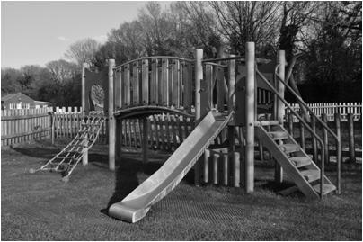
Provision of cycleways was given highest priority by respondents, when counting both first priorities only and all priorities for improvements to pedestrian and cycle routes, with 105 making a link to Thame their first or second priority, and similarly 94 wanting a cycleway to Wheatley.
We recommend :
- The PC develops a plan for a cycleway to link Tiddington to North Weston and thus Thame
- The PC develops a plan for a cycleway to link Tiddington to Wheatley
Planning and implementation of the cycleways will be a major task, including acquiring land, obtaining planning permission and undertaking significant construction work. This should be considered a long term proposition, especially in the current economic climate
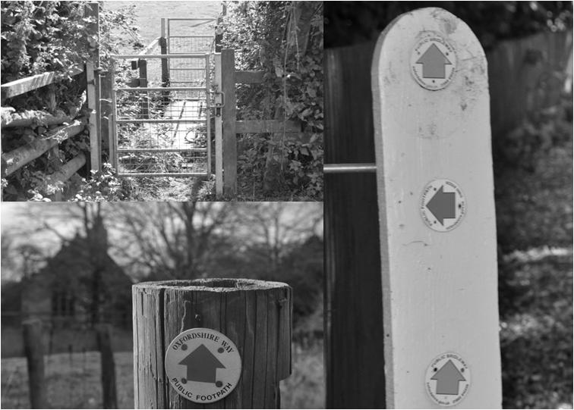
Broadband
A large majority of respondents have broadband but want faster connectivity. However only roughly one third would pay more than £10 monthly for increased speed.
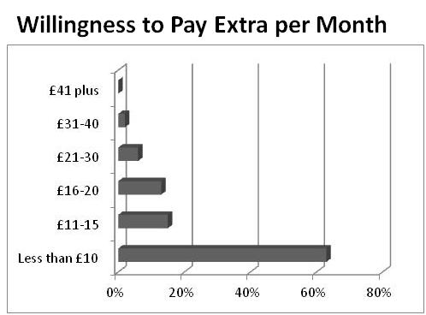
The broadband speeds are significantly higher in Tiddington, which is served by the Ickford exchange compared to the rest of the parish (served mainly from Great Milton). However less than one quarter of all broadband users in the parish have speeds greater than 4Mbps, which compares very poorly with the national average of 9Mbps.
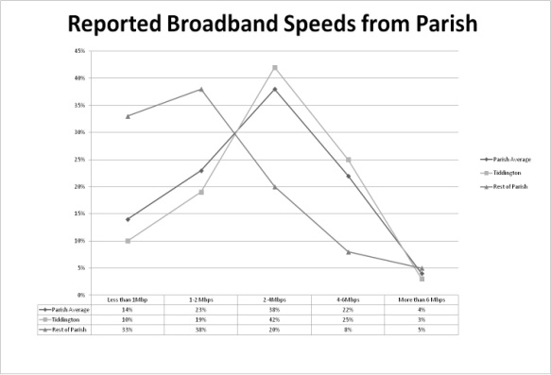
We recommend:
The PC continues to support and participate in the efforts of Broadband for Oxfordshire to improve broadband provision locally
Community Safety
37 written responses about community safety were received, with the biggest issues of concern being speeding (9 responses) and drug dealing (6). Seven other issues received 5 or less responses each.
We make no recommendations on this subject.
Economic Development
Most respondents viewed the provision of additional business premises positively whilst expressing concerns about the impact of additional traffic and possible growth of the built-up area
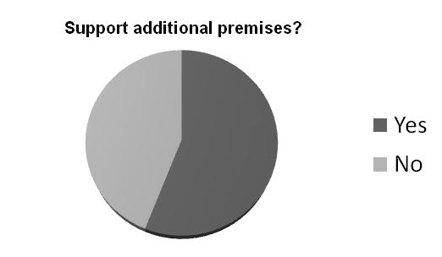
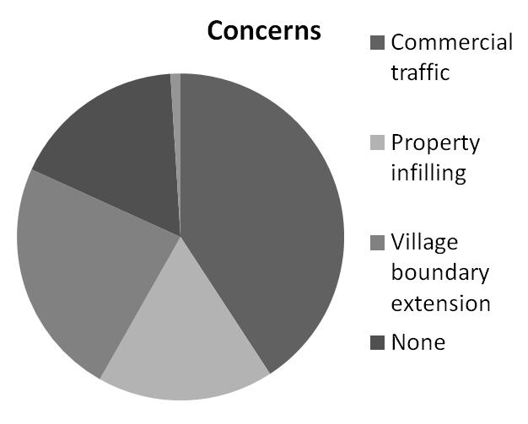
More than 140 respondents work at home at least occasionally, of whom more than 60 own or part own their business and thirty-one would be interested in a local networking event
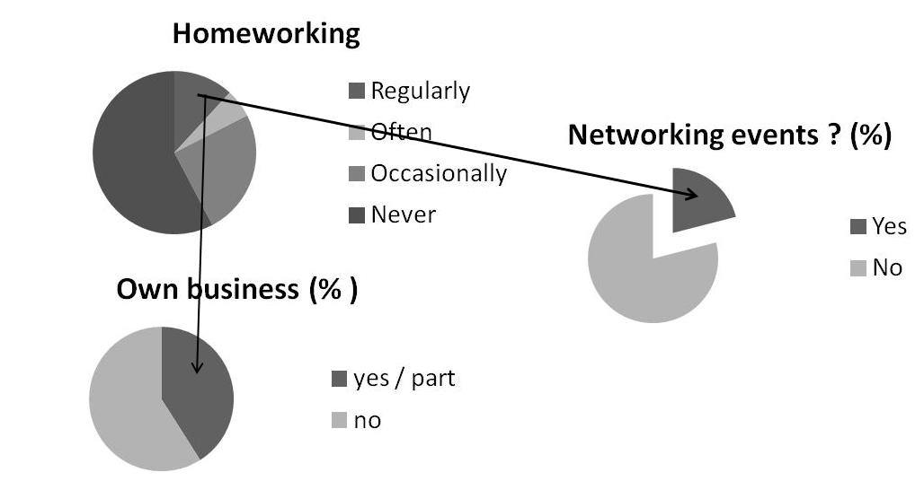
We recommend
- The PC organises a survey of potential business premises and assess their feasibility for use
- The PC identifies possible organisers of a local business networking event

The Plan
The tables below summarise all the recommendations of the plan and the proposed first steps to implement each one. The tables are divided into three time horizons, all from the date the plan is adopted by the parish council.
Short Term Issues
Recommendation | Proposed Next Action | Timescale | Note
Continue to press the case for a pelican crossing to the District and County Councils | Work with local county councillor David Turner to identify opportunities and times to put to OCC the case for a crossing | Agree approach over next 3 months | Timescale is for defining strategy, not getting the crossing
Organise increased levels of litter picking, utilising volunteers from the survey | Set dates for litter-picks over a 12 months period and advise volunteers identified through village plan survey | One month
Consider provision of additional litter and dog fouling bins | Identify possible locations and establish both set-up and running costs | Final decision on provision within 3 months | Parish council already investigating costs
Prepare a plan for identifying and penalising littering and dog fouling offenders | Signs are being erected in the playground already, therefore next action is to agree how to identify offenders and when/ how to penalise them | Agree approach and publicise it over the next 3 months | Challenge will be to identify offenders
Consider reintroduction of a public skip | Decide whether or not to re-introduce the service, and agree location and frequencies. | Within 3 months | Monthly skip hire cost is £175 (excluding VAT) for one day
Identify volunteers and check any statutory etc requirements for providing support to the elderly and the disabled | Prepare ideas for support services. Contact volunteers and arrange meeting to discuss survey results and ideas and to agree plans | Set-up meeting within next 3 months | There may need to be some funding support to implement this.  Need to draw in any existing suppliers of informal support to help get a co-ordinated approach.
Identify groups of interested people to plan and fundraise for the preferred leisure activities | Contact volunteers and arrange meeting to discuss survey results and ideas and to agree plans | Set-up meeting within next 3 months | There may need to be some funding support to implement this, though most activities should be self-funding.
Appoint an individual to oversee and co-ordinate the plans for the diverse range of leisure activities | Seek a volunteer, either from within the PC or externally, to act as the lead and co-ordinate the range of activities. | Find volunteer within next 3 months | If several separate activities are introduced we believe some co-ordination will help ensure they are launched successfully.
Investigate interest in and availability of schemes to support children and adolescents in neighbouring villages | Contact neighbouring parish councils to ascertain whether schemes to support children in the evenings or at week-ends are available or if there is unmet demand for them. | Obtain responses from councils within 6 months | Areas under consideration were weekend activities, youth club, school holiday care and after school care

Medium Term Issues
Recommendation | Proposed Next Action | Timescale | Note
Organise and support further fund raising for a pelican crossing | Identify leadership of the programme, agree schedule of fund-raising activities and financial targets | First activity to be commenced within 6 months | Very unlikely County Council will fund the crossing in the foreseeable future but the PC being able to make a significant contribution should increase chances significantly and helps the proposed campaign for one.
Investigate the installation of additional street lights further, and consult fully on any specific proposals | PC will need to identify possible locations, assess impacts/ value, and estimate costs | Initial proposals to be defined within 6 months | PC will need to consult fully with local residents as there were significant numbers of survey respondents in favour of and against the provision of more street lights.
Engage with the District Council and the Environment Agency to produce a local flood prevention and emergency management plan | First need to define scope of flood plan and respective responsibilities of PC, SODC and EA for its’ preparation | Define scope of plan and who does what within 6 months. | Problem of flooding apparently not significant to date here, but many respondents to survey agreed preparing a plan was important.
Identify problem stiles and contact landowners to replace them | Use Village Plan special report to identify problem areas | Contact all landowners within 6 months | Ultimate action will depend on landowners willingness to take action and provide funding
Establish a group to plan, improve and maintain the play facilities in the parish | Arrange meeting of volunteers, including those already helping maintain the playground and those responding in the recent survey, to agree how best to pro-actively develop and manage the playground. | Arrange meeting within 6 months. | Aim is to build on and strengthen current arrangements given new developments proposed and the additional volunteer support that has come forward.
Organise a survey of potential business premises and assess their feasibility for use | Identify volunteers to seek out and assess specific sites, using agreed criteria. | Agree criteria and organise survey within 6 months | This would be a first stage of a longer term process, needing to involve property owners and businesses seeking premises.
Identify possible organisers of a local business networking event | Seek volunteers from people living and working within the parish to set-up an initial business network event | Recruit interested parties within 6 months | This responds to interest identified in the recent survey. An initial event will test potential longer term interest. Help may be available from SODC.
Continue to support and participate in the efforts of Better Broadband for Oxfordshire to improve broadband provision locally. | Publicise the Better Broadband for Oxfordshire campaign locally and encourage more residents to become local broadband champions | Recruit new broadband champions in the next 6 months | Better Broadband for Oxfordshire is run by Oxfordshire County Council. More details are available at www.oxonline.co.uk

Long Term Issues
Recommendation | Proposed Next Action | Timescale | Note
Develop a plan for a cycleway to link Tiddington to North Weston, and therefore Thame | Identify possible route, contact landowners, prepare and cost design, acquire land | Complete the outline plan within 12 months | As costs will to be too high for parish council to fund, implementation will be long term given current likely obstacles
Develop a plan for a cycleway to link Tiddington with Wheatley | Identify possible route, identify and contact landowners, prepare and cost design, acquire land | Complete the outline plan within 18 months | As costs will to be too high for parish council to fund, implementation will be long term given current likely obstacles

Going Forward From Here
The plan as presented above represents the Village Plan Steering Committee’s interpretation of the wishes of the parish residents, drawing upon a series of informal gatherings of opinion followed, most importantly, by a questionnaire to all residents above the age of 10 years. Significantly, some 70% of our population returned responses to the questionnaire.
Not only did residents answer the questions posed to them but they came forward in large numbers with offers of support for a range of suggested activities that could be adopted from the plan. A total of 380 offers of support were received for activities ranging from helping the elderly, litter picking, helping to maintain the village hall and organising and participating in village games.
If the plan is to successfully deliver the desired improvements it will be important to build upon the momentum of support that has so far been generated. Crucial to this will be the on-going management of the process, which will largely be the responsibility of the parish council.
We have ideas on this subject that we would like to discuss with the parish council to hopefully enable a smoother passage for delivering the plan, including utilising the large body of volunteers to get their active involvement in the implementation process
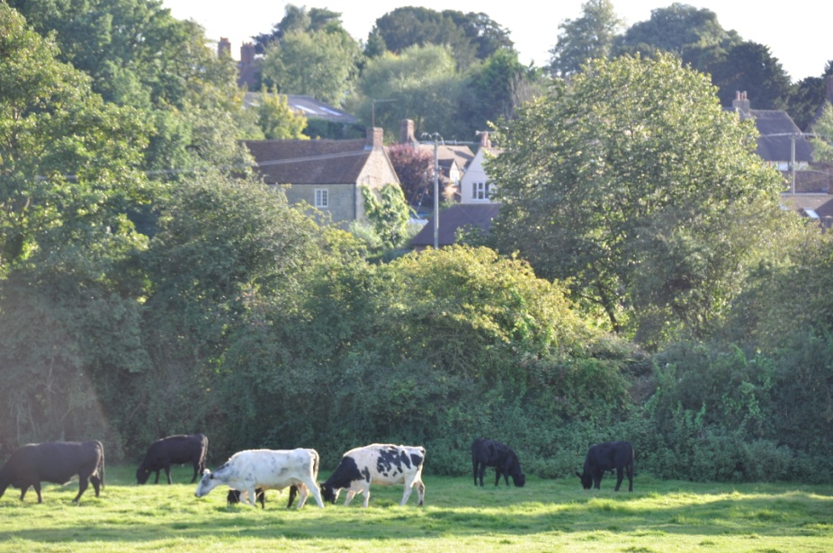

Acknowledgements
The Steering Group would like to acknowledge the support received from the following bodies:
Tiddington with Albury Parish Council
South Oxfordshire District Council
Oxfordshire County Council
David Turner, County Councillor
Oxfordshire Rural Communities Council, and in particular Anton Nath who helped us get started and has supported us throughout
Tiddington with Albury & Milton Common Newsletter, in particular Zena Knight
Tiddington Cricket Club, for hosting the monthly coffee mornings
We would also like to pay particular thanks to the local residents who volunteered to distribute and collect the questionnaire

Steering Group
The members of the Steering Group, some serving for only part of the planning period between August 2011 and April 2013, were:
Christine Craddock (chair)
Liz Booker
John Bull
Nigel Draper
Lyn Farrell
Tony Giddy
Chris Hill
Elaine Horne
Jenny Leslau
Ian Morris
Michelle Richardson
Rob Richardson
Jennie Sherlock-Williams
Jenny Stoker
Cate Teideman

Contact: Nigel Draper on 01844 339 347 or at drapernigelf@yahoo.co.uk

